Industrial Internship Report on
”Object Counter System”
Prepared by
[Seemant Sharma]

Executive Summary
This report provides details of the Industrial Internship provided by upskill Campus and The IoT Academy in collaboration with Industrial Partner UniConverge Technologies Pvt Ltd (UCT).
This internship was focused on a project/problem statement provided by UCT. We had to finish the project including the report in 6 weeks’ time.
My project was to make a object counter system. For which I made a bidirectional object counter system which is mostly used in malls to check the entry and exit of something.
This internship gave me a very good opportunity to get exposure to Industrial problems and design/implement solution for that. It was an overall great experience to have this internship.

TABLE OF CONTENTS
1 Preface 3
2 Introduction 4
2.1 About UniConverge Technologies Pvt Ltd 4
2.2 About upskill Campus 8
2.3 Objective 9
2.4 Reference 9
2.5 Glossary 10
3 Problem Statement 11
4 Existing and Proposed solution 12
5 Proposed Design/ Model 13
5.1 High Level Diagram (if applicable) 13
5.2 Low Level Diagram (if applicable) 13
5.3 Interfaces (if applicable) 13
6 Performance Test 14
6.1 Test Plan/ Test Cases 14
6.2 Test Procedure 14
6.3 Performance Outcome 14
7 My learnings 15
8 Future work scope 16

Preface
Summary of the whole 6 weeks’ work.
About need of relevant Internship in career development.
Brief about Your project/problem statement.
Opportunity given by USC/UCT.
How Program was planned
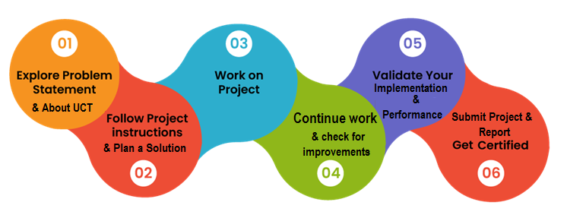
Your Learnings and overall experience.
Thank to all (with names), who have helped you directly or indirectly.
Your message to your juniors and peers.

Introduction

About UniConverge Technologies Pvt Ltd
A company established in 2013 and working in Digital Transformation domain and providing Industrial solutions with prime focus on sustainability and RoI.
For developing its products and solutions it is leveraging various Cutting Edge Technologies e.g. Internet of Things (IoT), Cyber Security, Cloud computing (AWS, Azure), Machine Learning, Communication Technologies (4G/5G/LoRaWAN), Java Full Stack, Python, Front end etc.
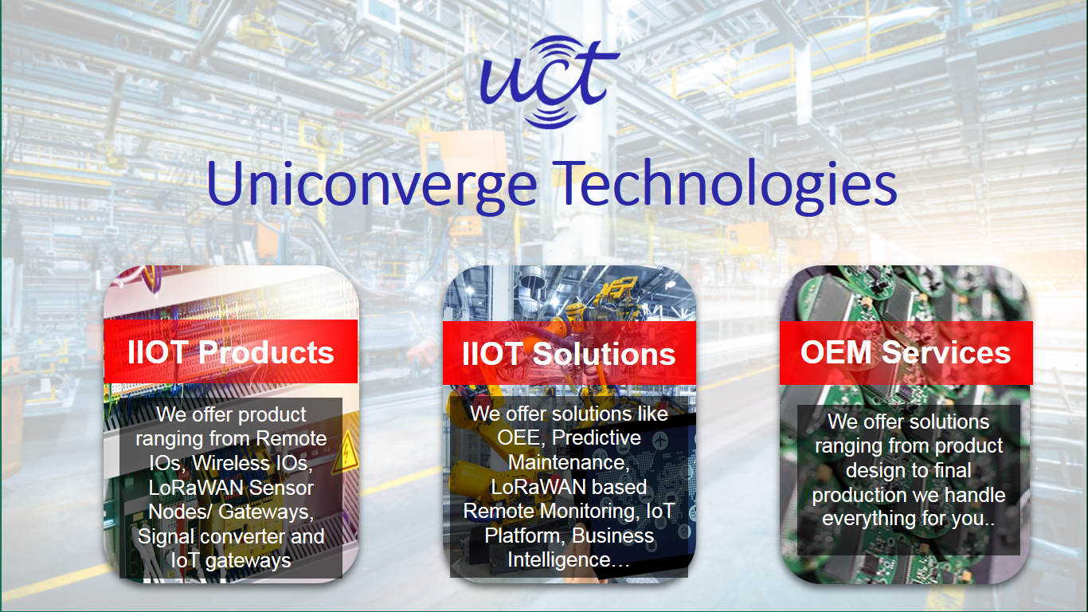
- UCT IoT Platform ()
UCT Insight is an IOT platform designed for quick deployment of IOT applications on the same time providing valuable “insight” for your process/business. It has been built in Java for backend and ReactJS for Front end. It has support for MySQL and various NoSql Databases.
- It enables device connectivity via industry standard IoT protocols - MQTT, CoAP, HTTP, Modbus TCP, OPC UA
- It supports both cloud and on-premises deployments.
It has features to
• Build Your own dashboard
• Analytics and Reporting
• Alert and Notification
• Integration with third party application(Power BI, SAP, ERP)
• Rule Engine

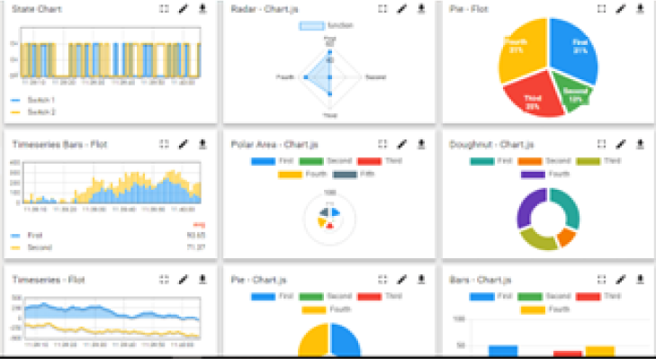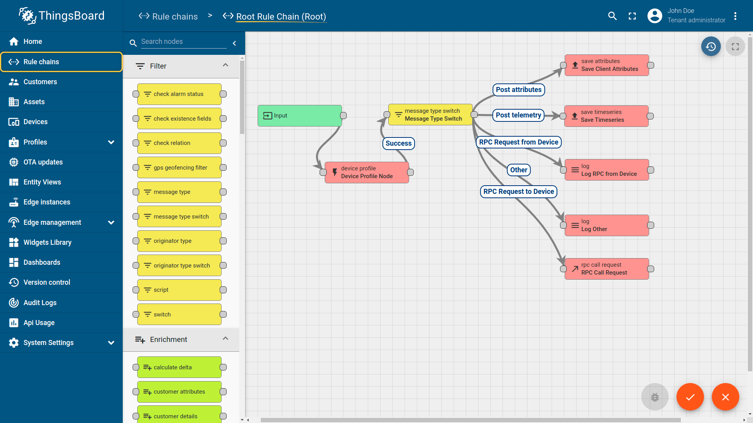

- Smart Factory Platform ()
Factory watch is a platform for smart factory needs.
It provides Users/ Factory
- with a scalable solution for their Production and asset monitoring
- OEE and predictive maintenance solution scaling up to digital twin for your assets.
- to unleased the true potential of the data that their machines are generating and helps to identify the KPIs and also improve them.
- A modular architecture that allows users to choose the service that they what to start and then can scale to more complex solutions as per their demands.
Its unique SaaS model helps users to save time, cost and money.
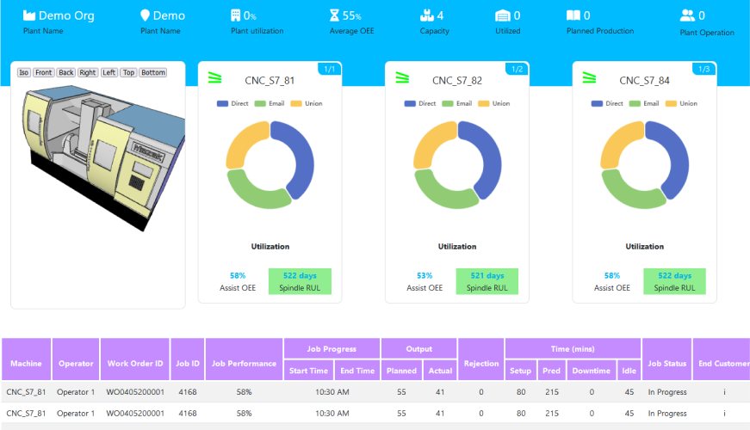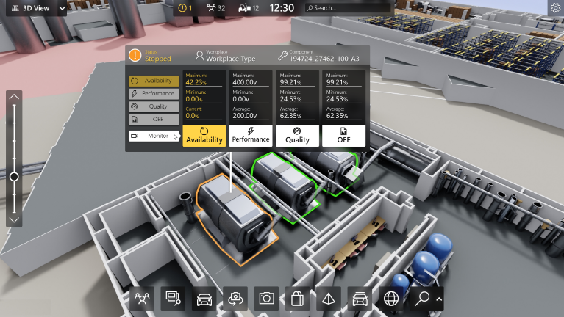

- 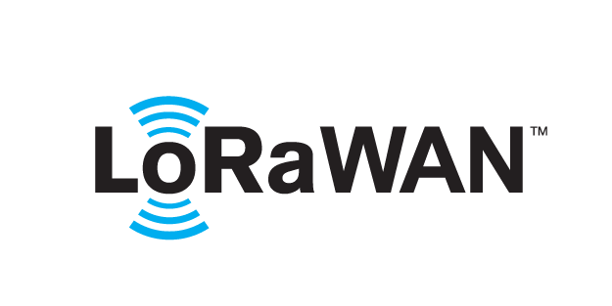 based Solution
UCT is one of the early adopters of LoRAWAN teschnology and providing solution in Agritech, Smart cities, Industrial Monitoring, Smart Street Light, Smart Water/ Gas/ Electricity metering solutions etc.
- Predictive Maintenance
UCT is providing Industrial Machine health monitoring and Predictive maintenance solution leveraging Embedded system, Industrial IoT and Machine Learning Technologies by finding Remaining useful life time of various Machines used in production process.
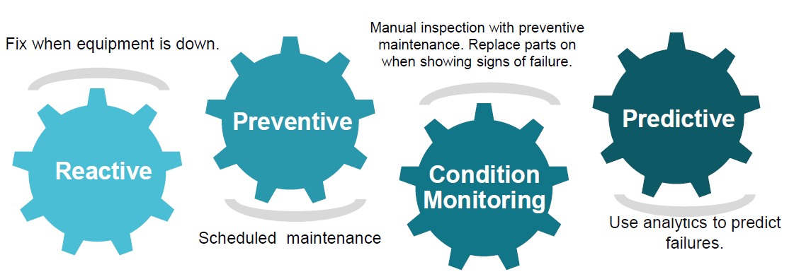

About upskill Campus (USC)
upskill Campus along with The IoT Academy and in association with Uniconverge technologies has facilitated the smooth execution of the complete internship process.
USC is a career development platform that delivers personalized executive coaching in a more affordable, scalable and measurable way.




Seeing need of upskilling in self paced manner along-with additional support services e.g. Internship, projects, interaction with Industry experts, Career growth Services
https://www.upskillcampus.com/
upSkill Campus aiming to upskill 1 million learners in next 5 year

Career growth/upskilling
Interview Preparation and skill building
upskilling Courses
Skill Assessment
Profile building
Professional networking
Alumni Connections
Mentorship
Discussion/QA forum
Collaboration platform
Project collaboration
Discussion forum
Tech updates
Job/internship platform
Job portal
Internship portal
Freelancing projects

The IoT Academy
The IoT academy is EdTech Division of UCT that is running long executive certification programs in collaboration with EICT Academy, IITK, IITR and IITG in multiple domains.

Objectives of this Internship program
The objective for this internship program was to
☛ get practical experience of working in the industry.
☛ to solve real world problems.
☛ to have improved job prospects.
☛ to have Improved understanding of our field and its applications.
☛ to have Personal growth like better communication and problem solving.

Reference
[1] First and for most you tube.
[2] Internet of things – a hands on approach by Arshdeep bahga and Vijay Madisetti
[3] IOT academy
[4] flux ai

Glossary
Terms | Acronym
Internet of things(iot) | The concept to allow Internet-based communications to happen between physical objects, sensors, and controllers. The network of physical objects—devices, vehicles, buildings, and other items that are embedded with electronics, software, sensors, and network connectivity, which enables these objects to collect and exchange data.
Gateway | A point on a network that receives information from many other points on the network and transmits information to another network. It can be physical (for example, the router for your home Internet) or embedded.
Near field communications | Low power, low speed, short range radio communication standard that allows two-way communication between endpoints within very close proximity

Problem Statement
The main problem that arises is lack of proper knowledge about softwares like Arduino ide, git hub, proteus and all. I was mostly troubled by the operation of these apps as we don’t have much knowledge about them. Even though we can found few tutorials about them on youtube but they are not much thorough.

Existing and Proposed solution
Currently ,we can solve most of our doubts about them using youtube but they are not thorough and correct as they don’t over look all the commands in the existing system which can help better in different conditions.
One tutorial should be available which teach us about the features of our applications like we have guides for our devices.

Code submission (Github link)
https://github.com/Seemant1920/UCTProject.git

Report submission (Github link)

https://github.com/Seemant1920/UCTReport.git

Proposed Design/ Model

Given more details about design flow of your solution. This is applicable for all domains. DS/ML Students can cover it after they have their algorithm implementation. There is always a start, intermediate stages and then final outcome.

High Level Diagram (if applicable)

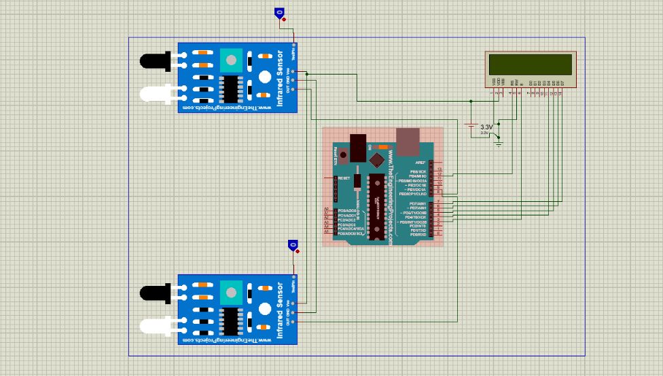

Figure 1: HIGH LEVEL DIAGRAM OF THE SYSTEM

Low Level Diagram (if applicable)

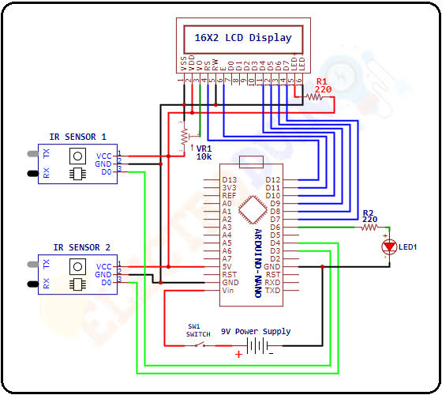

Interfaces (if applicable)

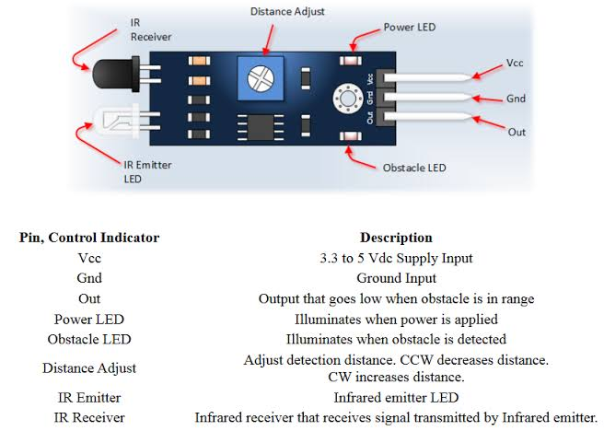

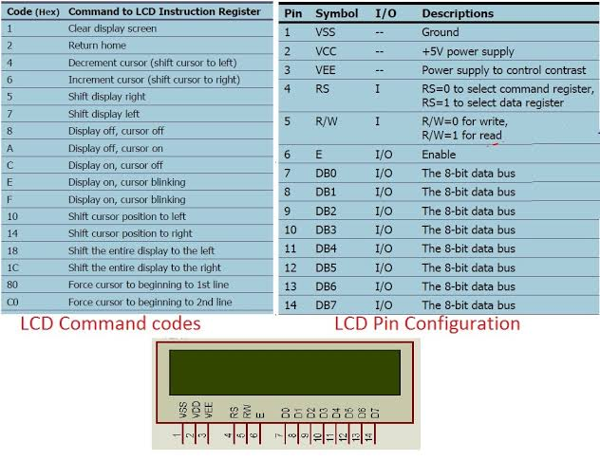

Performance Test

Performance is ok but speed is slow which can be changed through coding . There is one more problem of objects as it can not identify the objects. It only works on reflection of light due to which there are many restrictions to this project but it can said to be base of many security projects.

Test Plan/ Test Cases

Test Procedure

Performance Outcome

My learnings

The things I have learnt is basically how to operate arduino ide. And a little bit about arduino and other sensors.

Future work scope

In future I want to work on its ai aspect with the help of which we can easily distinguish between objects.

